Manatee Protection Zones

Regulations
Code of Federal Regulations -Manatee refuge waterborne activity restrictions
Florida Administrative Code - The Florida Manatee Sanctuary Act
City of Jacksonville Ordinance Code – Chapter 387 Manatee Protection
Manatee Protection Plan - Manatee Protection Zones and Maps for downtown

Important Note:
All federal, state and local regulations regarding speed zones are year-round.
Only the local ordinance allows single-event exemptions from local speed restrictions within certain sections of the St. Johns River if they meet specific conditions, limitations and procedures.

Code of Federal Regulations

Title 50 Chapter I Subchapter B Part 17 Subpart J Section 17.108

Definition Manatee refuge:
Manatee refuge means an area in which the Director has determined that certain waterborne activity would result in the taking of one or more manatees, or that certain waterborne activity must be restricted to prevent the taking of one or more manatees, including but not limited to a taking by harassment;

50 CFR Part 17.108(C) (11)
(c)Manatee refuges. The following areas are designated as manatee refuges. For each manatee refuge, we will state on appropriate signs which, if any, waterborne activities are prohibited, and state the applicable restrictions, if any, on permitted waterborne activities. The areas that will be posted are described as follows:
(11)The Lower St. Johns River Manatee Refuge.
(i) The Lower St. Johns River Manatee Refuge is described as portions of the St. Johns River and adjacent waters in Duval, Clay, and St. Johns Counties from Sandfly Point (the intersection of the right descending bank of the Trout River and the left descending bank of the St. Johns River) and Reddie Point, as marked, upstream to the mouth of Peter's Branch, including Doctors Lake, in Clay County on the western shore, and to the southern shore of the mouth of Julington Creek in St. Johns County on the eastern shore. A map showing the refuge and two maps showing specific areas of the refuge are at paragraph (11)(vi) of this section.
(ii) In the St. Johns River from Sandfly Point on the left descending bank of the St. Johns River and Reddie Point on the right descending bank of the St. Johns River, upstream to the Hart Bridge, a distance of approximately 5.5 miles (8.8 km), watercraft are required to proceed at slow speed, year-round, within 300 feet (91 m) of the shoreline on the left descending bank of the St. Johns River and within a buffer as marked, typically about 1,000 feet (305 m) from the shoreline along the right descending bank of the river. The slow speed designation also includes that portion of the river between Exchange Island and the right descending bank, a marked buffer approximately 300 feet (91 m) along the west (channel-ward) shoreline of Exchange Island, and a portion of the Arlington River as marked. Watercraft are also required to proceed at not more than 25 miles per hour (40 km/h), year round, in the area posted as such between these slow speed shoreline buffers. See map of “St. Johns River Bridges Area” in paragraph (11)(vi) of this section.
(iii) From the Hart Bridge to the Main Street Bridge, a distance of approximately 2 miles (3.2 km), watercraft are required to proceed at slow speed, year-round, outside the marked navigation channel and at speeds of not more than 25 miles per hour (40 km/h) in the marked channel (from Channel Marker “81” to the Main Street Bridge, the channel is defined as the line of sight extending west from Channel Markers “81” and “82” to the fenders of the Main Street Bridge). See map of “St. Johns River Bridges Area” in paragraph (11)(vi) of this section.
(iv) From the Main Street Bridge to the Fuller Warren Bridge, a distance of approximately 1 mile (1.6 km), shoreline to shoreline, watercraft are required to proceed at slow speed (channel included), year-round. See map of “St. Johns River Bridges Area” in paragraph (11)(vi) of this section.
(v) Upstream of the Fuller Warren Bridge: for a distance of approximately 19.3 miles (31.1 km) along the left descending bank of the St. Johns River, watercraft are required to proceed at slow speed, year-round, in a 700-foot (213 m) to 1,000-foot (305 m) as-marked, shoreline buffer from the Fuller Warren Bridge to the south bank of the mouth of Peter's Branch in Clay County; for a distance of approximately 20.2 miles (32.5 km) along the right descending bank of the St. Johns River, watercraft are required to proceed at slow speed, year round, in a 700-foot (213 m) to 1,000-foot (305 m) as marked, shoreline buffer from the Fuller Warren Bridge to the south bank of the mouth of Julington Creek in St. Johns County (defined as a line north of a western extension of the Nature's Hammock Road North); and in Doctors Lake in Clay County watercraft are required to proceed at slow speed, year-round, in a 700-foot (213 m) to 900-foot (274 m) as-marked, shoreline buffer (approximately 12.9 miles (20.8 km)). See map of “Lower St. Johns River” in paragraph (11)(vi) of this section.
(vi) Three maps of the Lower St. Johns River Manatee Refuge follow: 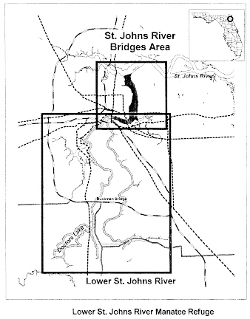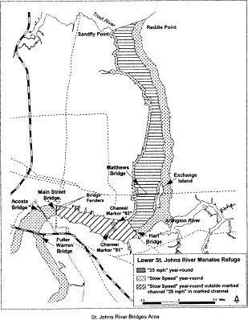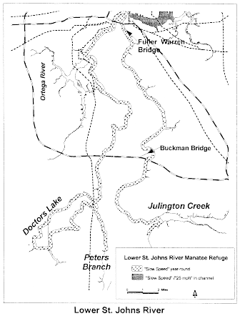

Florida Administrative Code

CHAPTER 68C-22

THE FLORIDA MANATEE SANCTUARY ACT

68C-22.027 Duval County and Associated County (Parts of Clay and St. Johns) Zones.
(1) The Commission hereby designates the waters within Duval County, Clay County, and St. Johns County, as described below, as areas where manatee sightings are frequent and where the best available information supports the conclusion that manatees inhabit these areas on a regular or periodic basis. The primary purpose of this rule is to protect manatees from harmful collisions with motorboats and from harassment by regulating the speed and operation of motorboats within these designated areas. A secondary purpose is to protect manatee habitat. In consideration of balancing the rights of fishers, boaters, and water skiers to use the waters of the state for recreational and commercial purposes (as applicable under Section 370.12(2)(k), F.S.), with the need to provide manatee protection, the Commission has examined the need for limited lanes, corridors, or unregulated areas that allow higher speeds through or within regulated areas. Such lanes, corridors, or areas are provided in those locations where the Commission determined that they are consistent with manatee protection needs. All of the zones set forth below are in effect year-round and, unless otherwise stated, all zones exclude all associated waterways (tributaries, lakes, creeks, coves, bends, backwaters, canals, basins, etc.) unless explicitly included.
(a) Slow Speed, Shore-to-Shore –
1. Atlantic Intracoastal Waterway, Sisters Creek – All waters of Sisters Creek, including the Atlantic Intracoastal Waterway Channel, south of an East-West line running through Flashing Green Atlantic Intracoastal Waterway Channel Marker “83” (approximate latitude 30° 24' 04" North, approximate longitude 81° 27' 16" West), and northeast of a line which bears 310° from the southwestern corner of a seawall at the southwestern tip of Fanning Island (approximate latitude 30° 23' 19" North, approximate longitude 81° 27' 41" West) and including those backwaters east of Sisters Creek lying southwest of a line which bears 140° from the southernmost tip of Shell Island (approximate latitude 30° 23' 52" North, approximate longitude 81° 27' 21" West);
2. Atlantic Intracoastal Waterway, South of the St. Johns River – All waters of the Atlantic Intracoastal Waterway, channel included, southwest of a line which bears 280° North from the westernmost tip (approximate latitude 30° 22' 44" North, approximate longitude 81° 27' 30" West) of a peninsula west of Sherman Point on the southern side of the St. Johns River, north of a line which bears 62° running through a point 600 feet north of and on a bearing of 332° from Flashing Green Atlantic Intracoastal Waterway Channel Marker “9” (approximate latitude 30° 22' 21" North, approximate longitude 81° 27' 01" West), northeast of the general contour of the northeastern shoreline of Great Marsh Island and a line which bears 137° from the easternmost tip of Great Marsh Island (approximate latitude 30° 22' 29" North, approximate longitude 81° 27' 17" West), and west of a line which bears 360° from the northernmost tip (approximate latitude 30° 22' 29" North, approximate longitude 81° 27' 05" West) of the unnamed island east of Green Atlantic Intracoastal Waterway Channel Marker “7”;
3. St. Johns River, Main Street Bridge to Fuller Warren Bridge Area – All waters of the St. Johns River and associated waterways west (upriver) of the Main Street Bridge and north (downriver) of the Fuller Warren Bridge;
4. Julington Creek and Durbin Creek Area – All waters of Julington Creek and Durbin Creek east of a line that bears 180° from a point (approximate latitude 30° 07' 59" North, approximate longitude 81° 36' 02" West) on the northern shoreline of Julington Creek at the mouth of Oilfield Creek and west of a line that bears 180° from a point (approximate latitude 30° 08' 01" North, approximate longitude 81° 35' 43" West) on the northern shoreline of Julington Creek 300 feet east of the southern extension of Hood Landing Road (and extending south across Durbin Creek to its southern shoreline).
(b) SLOW SPEED –
1. St. Johns River, St. Johns Point to Reddie Point – Those waters of the St. Johns River lying within 300 feet of the general contour of the northern and southern shorelines of the river, excluding the federally-marked channels, west of a line that runs from the northeasternmost point of St. Johns Point at the mouth of the river to the southeasternmost point of Wards Bank, east of a line which bears 360° from the easternmost point of Sandfly Point (approximate latitude 30° 23' 10" North, approximate longitude 81° 38' 03" West) across the mouth of the Trout River, and north of a line that runs from said easternmost point of Sandfly Point to the northernmost point of Reddie Point (approximate latitude 30° 23' 22" North, approximate longitude 81° 37' 13" West); included in this zone are those waters lying within 300 feet of the general contour of the shorelines of Blount Island and of the northern shoreline of Quarantine Island (Bartram Island) between the island's easternmost and westernmost points and those waters leading into Mayport Basin within 300 feet of the general contour of the shorelines, excluding the federally-marked channel, east of a line which bears 180° from the easternmost tip of the peninsula on the northern side of Mayport Basin (approximate latitude 30° 23' 51" North, approximate longitude 81° 24' 16" West); also included in this zone are those waters within 300 feet of the general contour of the shorelines of the Broward River and Dunn Creek south of the centerline of the Heckscher Drive (State Road 105) Bridges, and those waters within 300 feet of the general contour of the shorelines of all associated waterways on the north side of the river that are east of where Nichols Creek and San Carlos Creek enter the river and south of the centerline of the Heckscher Drive (State Road 105) Bridges, except as otherwise designated in paragraph (1)(a);
2. Mill Cove – Those waters within 300 feet of the general contour of the southern shoreline of Mill Cove, west of the westernmost point of Pauline Island and east of the northernmost point of Reddie Point (approximate latitude 30° 23' 22" North, approximate longitude 81° 37' 13" West);
3. Trout River – Those waters within 300 feet of the general contour of the shorelines of the Trout River west of a line that bears 360° from the easternmost point of Sandfly Point (approximate latitude 30° 23' 10" North, approximate longitude 81° 38' 03" West) across the mouth of the Trout River and east of the Interstate 95 Bridge;
4. St. Johns River, Reddie Point to Hart Bridge Area – Those waters described below, excluding the federally-marked Florida Intracoastal Waterway channel:
a. Within 300 feet of the general contour of the western (and northern) shoreline of the St. Johns River, south (upriver) of a line that runs from the easternmost point of Sandfly Point (approximate latitude 30° 23' 10" North, approximate longitude 81° 38' 03" West) to the northernmost point of Reddie Point (approximate latitude 30° 23' 22" North, approximate longitude 81° 37' 13" West) and north and east (downriver) of the Hart Bridge, including all associated waterways and all waters of Long Branch Creek easterly of the Buffalo Avenue/Wigmore Street Bridge;
b. Within 1,000 feet of the general contour of the eastern shoreline of the St. Johns River, south (upriver) of a line that runs from the easternmost point of Sandfly Point (approximate latitude 30° 23' 10" North, approximate longitude 81° 38' 03" West) to the northernmost point of Reddie Point (approximate latitude 30° 23' 22" North, approximate longitude 81° 37' 13" West) and north (downriver) of the Hart Bridge, including all associated waterways, and all waters east of Exchange Island and a line that bears 250° from the southernmost point of Exchange Island (approximate latitude 30° 19' 18'' North, approximate longitude 81° 37' 05'' West) and west of a line that bears 73° from a point (approximate latitude 30° 18' 53'' North, approximate longitude 81° 36' 43'' West) on the southern shoreline of the Arlington River at the mouth of Little Pottsburg Creek; and also including those waters within 300 feet of the general contour of the western shoreline of Exchange Island.
5. St. Johns River, Hart Bridge to Main Street Bridge Area – All waters of the St. Johns River and associated waterways, including all waters of Miller Creek north of the Atlantic Boulevard (State Road 10) Bridge, west (upriver) of the Hart Bridge and east (downriver) of the Main Street Bridge, except in the marked channel of the Florida Intracoastal Waterway as designated in sub-paragraph (1)(c)2.
6. St. Johns River, Fuller Warren Bridge to the South Duval County Line – Those waters of the St. Johns River, south of the centerline of the Fuller Warren Bridge, north of the centerline of the Buckman (Interstate 295) Bridge (the Duval County/Clay County line) on the western shore, and west and north of the centerline of the San Jose Boulevard (State Road 13) Bridge crossing Julington Creek on the eastern shore, including: those waters of Big Fishweir Creek east of the centerline of the Herschel Street Bridge; those waters northeast of and within 500 feet of the centerline of the Ortega (Grand Avenue) Bridge; those waters of Pirates Cove (also referred to as the Venetia Yacht Basin); those waters of Mulberry Cove northwest of a line that runs from a point (approximate latitude 30° 13' 05" North, approximate longitude 81° 40' 31" West) on the northern shoreline of the cove to another point (approximate latitude 30° 12' 56" North, approximate longitude 81° 40' 46" West) on the southern shoreline; those waters of Marco Lake; those waters of Craig Creek west of the centerline of the Hendricks Avenue (State Road 13) Bridge; and those waters of Goodby’s Creek. Except for the waters northeast of the Ortega (Grand Avenue) Bridge as described above, the waters described in this paragraph shall be subject to a variable-width shoreline buffer whose width is as set forth in subsection (2), of this rule;
7. Ortega River Area – Those waters within 300 feet of the general contour of the shorelines of the Ortega River, including all associated waterways, south of the centerline of the Ortega (Grand Avenue) Bridge, north of the centerline of the Timuquana Bridge for the buffer along the eastern shoreline, and east of the southernmost point (approximate latitude 30° 15' 57" North, approximate longitude 81° 43' 36" West) of the peninsula that forms the northern shoreline of the Cedar River for the buffer along the western shoreline, including all waters within 300 feet south of the centerline of the Ortega (Grand Avenue) Bridge and all waters within 300 feet of either side of the Roosevelt Boulevard Bridge;
8. Julington Creek – All waters of Julington Creek within 450 feet of either side of the centerline of the San Jose Boulevard (State Road 13) Bridge and those waters within 300 feet of the general contour of the shorelines of Julington Creek and all associated waterways east of the centerline of the San Jose Boulevard (State Road 13) Bridge and west of a line that bears 180° from a point (approximate latitude 30° 07' 59" North, approximate longitude 81° 36' 02" West) on the northern shoreline of Julington Creek at the mouth of Oilfield Creek;
9. St. Johns River in St. Johns County, Julington Creek to Nature’s Hammock Road North – Those waters of the St. Johns River in St. Johns County, west and south of the centerline of the San Jose Boulevard (State Road 13) Bridge, and north of the western extension of Nature’s Hammock Road North. The waters described in this paragraph shall be subject to a variable-width shoreline buffer whose width is as set forth in subsection (2), of this rule;
10. St. Johns River in Clay County, Buckman Bridge to Peter Branch – Those waters of the St. Johns River in Clay County, south of the centerline of the Buckman (Interstate 295) Bridge and north of a line that bears 90° from a point on the shoreline (approximate latitude 30° 06' 05" North, approximate longitude 81° 41' 24"' West) located 300 feet south of Peter Branch. The waters described in this paragraph shall be subject to a variable-width shoreline buffer whose width is as set forth in subsection (2), of this rule;
11. Doctors Lake and Doctors Inlet Area – Those waters of Doctors Lake, Duck Creek, and Swimming Pen Creek, and including those waters of Doctors Inlet 500 feet of either side of the centerline of the US Highway 17 Bridge. Except for the waters of Doctors Inlet described above, the waters described in this paragraph shall be subject to a variable-width shoreline buffer whose width is as set forth in subsection (2), of this rule.
(c) 25 MPH
1. St. Johns River, Reddie Point to Hart Bridge Area – All waters of the St. Johns River outside of the Slow Speed areas designated in subparagraph (1)(b)4.;
2. St. Johns River, Hart Bridge to Main Street Bridge Area – All waters in the marked channel of the Florida Intracoastal Waterway west (upriver) of the Hart Bridge and east (downriver) of the Main Street Bridge.
(2) The width of the variable-width shoreline buffer referenced in subparagraphs (1)(b)6., 9., 10., and 11., above is as follows: The buffer includes at a minimum all waters within 500 feet of the general contour of the shoreline. Where there are docks that extend out farther than 300 feet into the waterway, the buffer extends out beyond the 500-foot line to include all waters shoreward of a line that runs 200 feet beyond and parallel to the dock line. For the purposes of this rule, the dock line shall be defined as a line that runs between the ends of successive docks.
(3) The zones described in subsection 68C-22.027(1), F.A.C., above are depicted on the following maps, labeled “Duval and Associated County Manatee Protection Zones”. The maps are intended to be depictions of the above-described zones. In the event of a conflict between the two, the above descriptions shall prevail.
(4) The amendments to Rule 68C-22.027, F.A.C., as approved by the Commission on December 6, 2006, shall take effect as soon as the regulatory markers are posted.
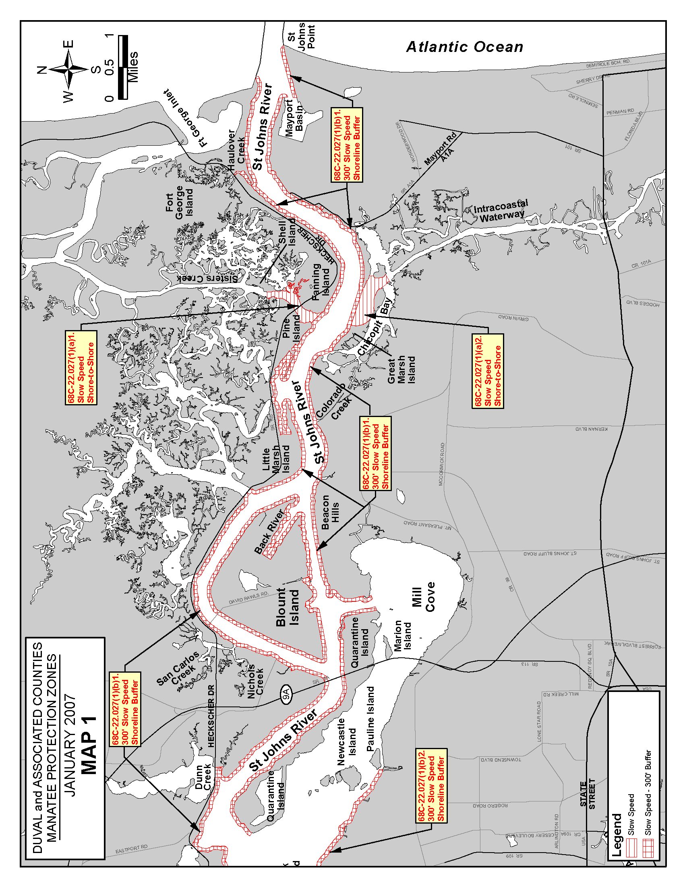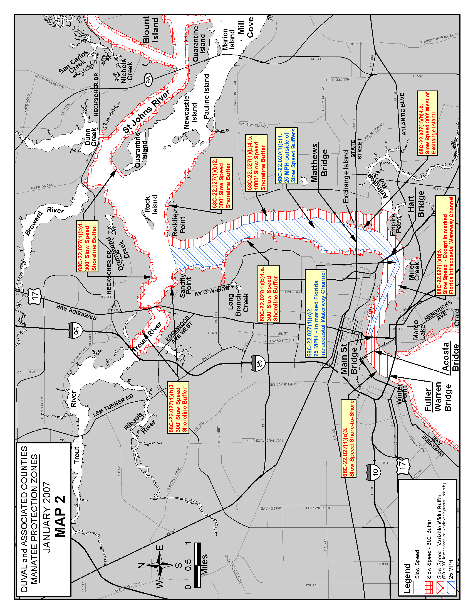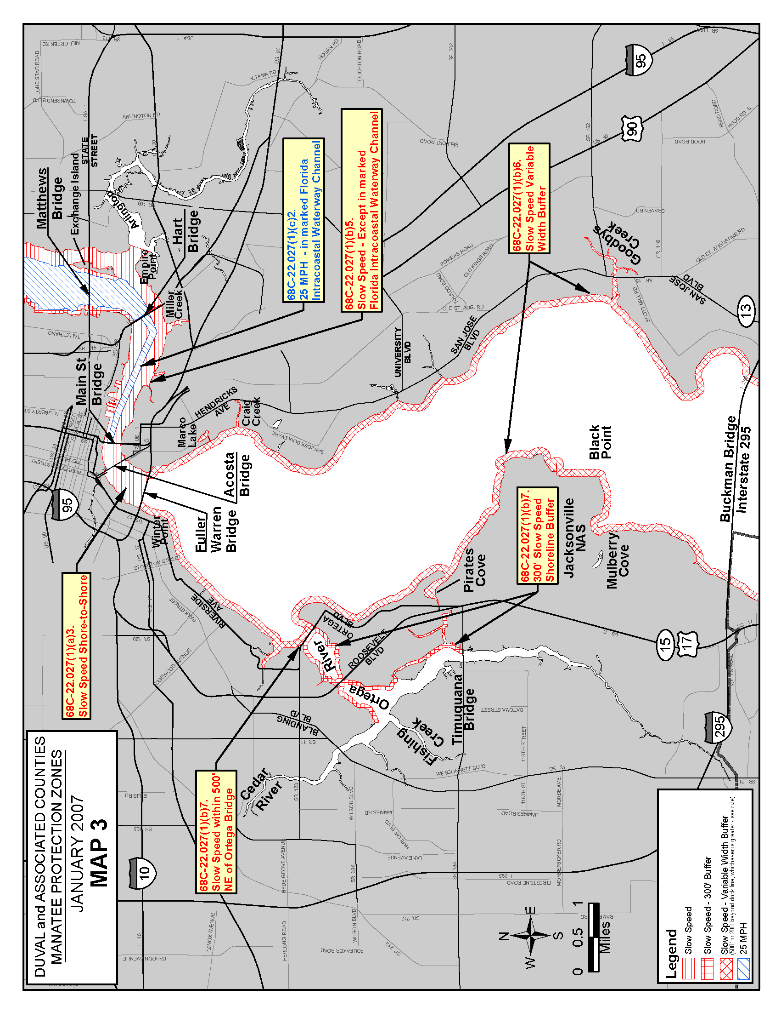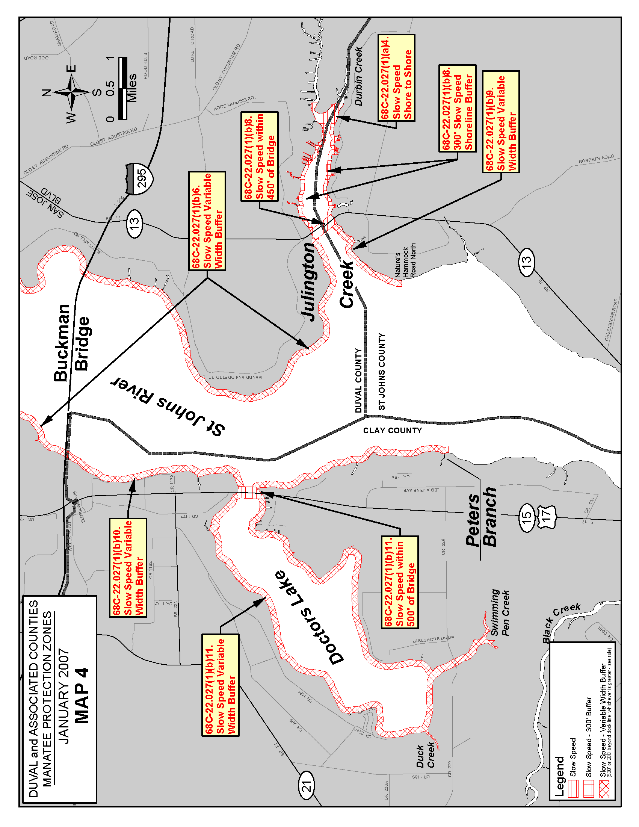
Rulemaking Authority 370.12(2)(n) FS. Law Implemented 370.12(2)(d), (k), (n) FS. History–New 12-22-92, Amended 6-16-93, Formerly 16N-22.027, 62N-22.027, Amended 8-1-00, 1-30-07.
City of Jacksonville Ordinance Code
Chapter 387 - MANATEE PROTECTION

Sec. 387.101. - Findings.
The Council finds that human activities are the greatest identifiable causes of manatee deaths in Florida and that there is justification for implementing speed regulations on some portions of the lower St. Johns River based on the degree of mortality in manatee use. The Council believes a site specific manatee protection plan provides the greatest protection for the manatee while still preserving portions of the St. Johns River for recreational boating and water sports activities. This concept has been recommended and endorsed by the Jacksonville Waterways Commission.
(Ord. 97-651-E, § 5)

Sec. 387.102. - Definitions.
As used in this Chapter:
(a) Caution zone means an area where manatees frequently inhabit on a somewhat regular basis and motorboat operators are advised to use caution so as not to strike a manatee.
(b) Slow speed zone means an area where motorboats may not be operated at greater than slow speed, as defined in Rule 68C-22.002, Florida Administrative Code.
(c) Shore line means the point where the water meets the land at any point in time.
(d) General contour of the shore line has the meaning described in Rule 68C-22.002, Florida Administrative Code.
(e) Motor boat means any boat or vessel propelled or powered by machinery.
(f) Waters means those waters of the State of Florida within the territorial jurisdiction of Duval County.
(g) Idle speed zone means an area where motorboats may not be operated at greater than idle speed, as defined in Rule 68C-22.002(1), Florida Administrative Code.
(Ord. 97-651-E, § 5; Ord. 2000-937-E, § 1; Ord. 2004-956-E, § 2; Ord. 2007-730-E, § 2)

Sec. 387.103. - Manatee protection zones.
(1) Except in the marked navigation channels of the Atlantic Intracoastal Waterway and the St. Johns River and the area within 100 feet of such channels, the following waters within Duval County are designated manatee protection zones. The zones set forth below are in effect year-round and, unless otherwise stated, all zones exclude all associated waterways (tributaries, creeks, coves, bends, backwaters, canals, basin, etc.) unless explicitly included.
(a) Slow speed, shore-to-shore.
1. Atlantic Intracoastal Waterway, Sisters Creek. All waters of Sisters Creek, except in the marked navigation channel of Intracoastal Waterway and the area within 100 feet of such channel, south of an east-west line running through Flashing Green Atlantic Intracoastal Waterway Channel Marker "83" (approximate latitude 30°24′04″ north, approximate longitude 81°27′16″ west), and northeast of a line which bears 310° from the southwestern corner of a seawall at the southwestern tip of Fanning Island (approximate latitude 30°23′19″ north, approximate longitude 81°27′41″ west) and including those backwaters east of Sisters Creek lying southwest of a line which bears 140° from the southernmost tip of Shell Island (approximate latitude 30°23′52″ north, approximate longitude 81°27′21″ west);
2. Atlantic Intracoastal Waterway, South of the St. Johns River. All waters of the Atlantic Intracoastal Waterway, except the channel and the area within 100 feet of such channel, southwest of a line which bears 280° north from the westernmost tip (approximate latitude 30°22′44″ north, approximate longitude 81°27′30″ west) of a peninsula west of Sherman Point on the southern side of the St. Johns River, north of a line which bears 62° running through a point 600 feet north of and on a bearing of 332° from Flashing Green Atlantic Intracoastal Waterway Channel Marker "9" (approximate latitude 30°22′21″ north, approximate longitude 81°27′01″ west), northeast of the general contour of the northeastern shoreline of Great Marsh Island and a line which bears 137° from the easternmost tip of Great Marsh Island (approximate latitude 30°22′29″ north, approximate longitude 81°27′17″ west), and west of a line which bears 360° from the northernmost tip (approximate latitude 30°22′29″ north, approximate longitude 81°27′05″ west) of the unnamed island east of Green Atlantic Intracoastal Waterway Channel Marker "7;"
3. St. Johns River, Main Street Bridge to Fuller Warren Bridge Area. All waters of the St. Johns River and associated waterways west (upriver) of the Main Street Bridge and north (downriver) of the Fuller Warren Bridge;
4. Julington Creek and Durbin Creek Area. All waters of Julington Creek and Durbin Creek east of a line that bears 180° from a point (approximate latitude 30°07′59″ north, approximate longitude 81°36′02″ west) on the northern shoreline of Julington Creek at the mouth of Oldfield Creek and west of a line that bears 180° from a point (approximate latitude 30°08′01″ north, approximate longitude 81°35′43″ west) on the northern shoreline of Julington Creek 300 feet east of the southern extension of Hood Landing Road (and extending south across Durbin Creek to its southern shoreline).
(b) Slow speed.
1. St. Johns River, St. Johns Point to Reddie Point. Those waters of the St. Johns River lying within 300 feet of the general contour of the northern and southern shorelines of the river, excluding the federally-marked channels, west of a line that runs from the northeasternmost point of St. Johns Point at the mouth of the river to the southeasternmost point of Wards Bank, east of a line which bears 360° from the easternmost point of Sandfly Point (approximate latitude 30°23′10″ north, approximate longitude 81°38′03″ west) across the mouth of the Trout River, and north of a line that runs from said easternmost point of Sandfly Point to the northernmost point of Reddie Point (approximate latitude 30°23′22″ north, approximate longitude 81°37′13″ west); included in this zone are those waters lying within 300 feet of the general contour of the shorelines of Blount Island and of northern shoreline of Quarantine Island (Bartram Island) between the island's easternmost and westernmost points and those waters leading into Mayport Basin within 300 feet of the general contour of the shorelines, excluding the federally-marked channel, east of a line which bears 180° from the easternmost tip of the peninsula on the northern side of Mayport Basin (approximate latitude 30°23′51″ North, approximate longitude 81°24′16″ West); also included in this zone are those waters within 300 feet of the general contour of the shorelines of the Broward River and Dunn Creek south of the centerline of the Heckscher Drive (State Road 105) Bridges, and those waters within 300 feet of the general contour of the shorelines of all associated waterways on the north side of the river that are east of where Nichols Creek and San Carlos Creek enter the river and south of the centerline of the Heckscher Drive (State Road 105) Bridges, except as otherwise designated in (a);
2. Mill Cove. Those waters within 300 feet of the general contour of the southern shoreline of Mill Cove, west of the westernmost point of Pauline Island and east of the northernmost point of Reddie Point (approximate latitude 30°23′22″ north, approximate longitude 81°37′13″ west);
3. Trout River. Those waters within 300 feet of the general contour of the shorelines of the Trout River west of a line that bears 360° from the easternmost point of Sandfly Point (approximate latitude 30°23′10″ north, approximate longitude 81°38′03″ west) across the mouth of the Trout River and east of the Interstate 95 Bridge;
4. St. Johns River, Reddie Point to Hart Bridge Area. Those waters described below, excluding the federally-marked Florida Intracoastal Waterway channel and the area within 100 feet of such channel:
a. Within 300 feet of the general contour of the western (and northern) shoreline of the St. Johns River, south (upriver) of a line that runs from the easternmost point of Sandfly Point (approximate latitude 30°23′10″ north, approximate longitude 81°38′03″ west) to the northernmost point of Reddie Point (approximate latitude 30°23′22″ north, approximate longitude 81°37′13″ west) and north and east (downriver) of the Hart Bridge, including all associated waterways and all waters of Long Branch Creek easterly of the Buffalo Avenue/Wigmore Street Bridge;
b. Within 1,000 feet of the general contour of the eastern shoreline of the St. Johns River, south (upriver) of a line that runs from the easternmost point of Sandfly Point (approximate latitude 30°23′10″ north, approximate longitude 81°38′03″ west) to the northernmost point of Reddie Point (approximate latitude 30°23′22″ north, approximate longitude 81°37′13″ west) and north (downriver) of the Hart Bridge, including all associated waterways, and all waters east of Exchange Island and a line that bears 250° from the southernmost point of Exchange Island (approximate latitude 30°19′18″ North, approximate longitude 81°37′05″ West) and west of a line that bears 73° from a point (approximate latitude 30°18′53″ North, approximate longitude 81°36′43″ West) on the southern shoreline of the Arlington River at the mouth of Little Pottsburg Creek; and also including those waters within 300 feet of the general contour of the western shoreline of Exchange Island
5. St. Johns River, Hart Bridge to Main Street Bridge Area. All waters of the St. Johns River and associated waterways, including all waters of Miller Creek north of the Atlantic Boulevard (State Road 10) Bridge, west (upriver) of the Hart Bridge and east (downriver) of the Main Street Bridge.
6. St. Johns River, Fuller Warren Bridge to the South Duval County Line. Those waters of the St. Johns River south of the centerline of the Fuller Warren Bridge, north of the centerline of the Buckman (Interstate 295) Bridge (the Duval County/Clay County line) on the western shore, and west and north of the centerline of the San Jose Boulevard (State Road 13) Bridge crossing Julington Creek on the eastern shore, including those waters of Big Fishweir Creek east of the centerline of the Herschel Street Bridge; those waters northeast of and within 500 feet of the centerline of the Ortega (Grand Avenue) Bridge; those waters of Pirates Cove (also referred to as the Venetia Yacht Basin); those waters of Mulberry Cove northwest of a line that runs from a point (approximate latitude 30°13′05″ north, approximate longitude 81°40′31″ west) on the northern shoreline of the cove to another point (approximate latitude 30°12′56″ north, approximate longitude 81°40′46″ west) on the southern shoreline; and those waters of Marco Lake; those waters of Craig Creek west of the centerline of the Hendricks Avenue (State Road 13) Bridge. Except for the waters northeast of the Ortega (Grand Avenue) Bridge as described above, the waters described in this paragraph shall be subject to a variable-width shoreline buffer whose width is as set forth in section (2) of this section;
7. Ortega River Area. Those waters within 300 feet of the general contour of the shorelines of the Ortega River, including all associated waterways, south of the centerline of the Ortega (Grand Avenue) Bridge, north of the centerline of the Timuquana Bridge for the buffer along the eastern shoreline, and east of the southernmost point (approximate latitude 30°15′57″ north, approximate longitude 81°43′36″ west) of the peninsula that forms the northern shoreline of the Cedar River for the buffer along the western shoreline and a 100-foot buffer along the western shoreline of Ortega Island, including all waters within 300 feet south of the centerline of the Ortega (Grand Avenue) Bridge and all waters within 300 feet of either side of the Roosevelt Boulevard Bridge;
8. Julington Creek. All waters of Julington Creek within 450 feet of either side of the centerline of the San Jose Boulevard (State Road 13) Bridge and those waters within 300 feet of the general contour of the shorelines of Julington Creek and all associated waterways, east of the centerline of the San Jose Boulevard (State Road 13) Bridge and west of a line that bears 180° from a point (approximate latitude 30°07′59″ north, approximate longitude 81°36′02″ west) on the northern shoreline of Julington Creek at the mouth of Oldfield Creek;
(c) 25 mph. St. Johns River, Reddie Point to Hart Bridge Area. All waters of the St. Johns River outside of the slow speed areas designated in subparagraph (1)(b)4.
(2) The width of the variable-width shoreline buffer referenced in paragraph (1)(b)6., above is as follows: The buffer includes at a minimum all waters within 500 feet of the general contour of the shoreline. Where there are docks that extend out farther than 300 feet into the waterway, the buffer extends out beyond the 500-foot line to include all waters shoreward of a line that runs 200 feet beyond and parallel to the dock line. The dock line is defined as a line that runs between the ends of successive docks.
(3) Caution zones. Caution zones are hereby established for the following waterways:
(a) Dunn Creek.
(b) Broward River.
(c) Trout River from I-95 Bridge to the headwaters.
(d) Arlington River and Pottsburg Creek from inside the mouth of the Arlington River to the headwaters.
(e) Cedar River from its mouth to the headwaters.
(f) Ortega River from the Timuquana Bridge to the headwaters. Julington and Durbin Creeks from 300 feet east of the Hood Landing Boat Ramp to the headwaters.
(4) Idle speed zone. An idle speed zone is hereby established in the waters of Goodby's Creek east of Day Marker #1 at the mouth of the creek.
(5) The zones described above are coextensive with zones established by Rule 68C-22.027, Florida Administrative Code and are depicted on maps, entitled "Duval and Associated County Manatee Protection Zones" and attached thereto. In the event of conflict between the descriptions and map depictions, the above descriptions shall prevail.
(Ord. 97-651-E, § 5; Ord. 2000-937-E, § 2; Ord. 2004-956-E, § 3; Ord. 2007-125-E, § 1; Ord. 2007-730-E, § 2)
Sec. 387.104. - Exemptions.
(1) Single-event exemptions from local speed restrictions within certain sections of the St. Johns River for the purpose of powerboat racing demonstrations, ski shows and similar events may be granted. The following conditions, limitations and procedures for application apply:
(a) For each event for which an exemption is requested, an application for a variance from Rule 68C-22.027, Florida Administrative Code shall be submitted to the Florida Fish and Wildlife Conservation Commission 620 South Meridian Street, Tallahassee, FL 32399, and a copy of the variance application shall be submitted to the Jacksonville Waterways Commission, City Hall-St. James, Suite 425, 117 West Duval Street, Jacksonville, Florida 32202, at least 90 days prior to the event. In addition to information required by the F.S. Ch. 120 and state rules, the variance application shall clearly state:
(i) The nature and scope of the boat race, ski show or other event, including estimated numbers and nature/configuration of vessels involved and maximum speeds anticipated.
(ii) The specific area within which the event will be conducted described in the letter of application and depicted on a National Ocean Survey nautical chart;
(iii) The month and day (if known) of the event; and
(iv) Justification for holding the event within waters regulated for manatee protection, clearly demonstrating why no alternative site is suitable for the event.
(b) Single-event exemptions from local speed restrictions will be considered only for events to be conducted along the St. Johns River between the Hart and Acosta Bridges and only for events to be conducted during daylight hours.
(c) Upon receipt of a variance from the Florida Fish and Wildlife Conservation Commission and a letter from the Jacksonville Waterways Commission granting the exemption, the recipient shall comply with all nonexempt provisions of this chapter and with all conditions and limitations of the variance issued by the Fish and Wildlife Conservation Commission and the nontransferrable letter of exemption issued by the Jacksonville Waterways Commission, as well as with any specific notice requirements as may be requested by the Jacksonville Sheriff's Office. Failure to comply with the exemption conditions, and any finding of fraudulent use and/or application for said exemption, shall be cause for its immediate revocation, including suspension of exemption privileges prior to, or during, the exempted event.
(d) The recipient shall also comply with all other conditions (and/or determinations issued concurrent with, or subsequent to, said letter-of-exemption) as may be specified by the U.S. Coast Guard and other appropriate state or federal authorities as they may relate to manatee protection.
(2) Exemptions for commercial fishermen, fishing guides and others are provided in Rule 68C-22.003, Fla. Admin. Code, which is adopted by reference. Any person entitled to an exemption under that rule is exempt from comparable local restrictions.
(Ord. 97-651-E, § 5; Ord. 2000-937-E, § 3; Ord. 2007-730-E, § 2)
Sec. 387.105. - Penalties.
Unless exempt under Section 387.104, any person operating a motorboat in a manatee protection area in excess of the designated motorboat speed limit shall be guilty of a noncriminal offense punishable by a civil penalty of $50, which civil penalty shall be paid to the Tax Collector in a manner similar to the provisions for payment of civil penalties as prescribed by F.S. § 327.73. This Chapter may be enforced by officers of the Jacksonville Sheriff's Office, the Florida Marine Patrol, and the Florida Fish and Wildlife Conservation Commission.
(Ord. 97-651-E, § 5; Ord. 2000-937-E, § 1)

Duval County Manatee Protection Plan 4th Edition

Manatee Protection Zones

Section 2.1.1.2.3.2
Manatee protection rules are rules that are established by FWC to restrict the speed and operation of vessels to protect manatees from harmful collisions with vessels and from harassment. The rationale for reducing vessel speeds to reduce risks to manatees is discussed in a peer-reviewed paper by FWC staff authored in 2007 (Calleson and Frohlich 2007). In areas that are especially important to manatees, the rules can prohibit or limit entry into an area as well as restrict what activities can be performed in the area. FWC is authorized to adopt these rules by the Manatee Sanctuary Act, 379.2431(2), Florida Statutes (FS). The rules appear in Chapter 68C-22 of the FAC. The rule process is started when the FWC evaluates all available information and determines that a new or amended rule may be warranted. The initial step of identifying an area to be evaluated can be undertaken internally by FWC or can be done by someone outside of FWC by submitting a request. The 2007 MMP describes the factors FWC considers when prioritizing areas to be reviewed. Many different factors are considered when the need for a rule is evaluated. The most important factors are typically the amount and types of manatee use and boating use in the area in light of the available habitat and waterway characteristics (depth, visibility, width of the waterway, etc.).

Local governments can also establish manatee protection zones through the adoption of a local ordinance. These zones must be approved by FWC before they can take effect, as required by 379.2431(2)(p), FS. Local manatee protection zones cannot include waters within the main marked channel of the Florida Intracoastal Waterway or waters within 100 feet thereof. In the COJ, Federal, State and local Manatee Protection Zones almost mirror the other agencies’ zones so that the rules are less complicated for the boating public and manatee protection restrictions within the zone areas can be enforced by all the enforcement agencies.

Regulatory zones (Figures 4 - 8) are designated by signs along waterways. Signs provide information regarding the boundary of a zone, its regulated speed, and the area of regulation. Regulatory zones are to be enforced by the appropriate law enforcement agencies. The state Manatee Protection Zones in Duval County (68C-22.027 FAC) were last amended January 2007. The FWC Boating and Waterways section installs and maintains manatee protection zone signs. A program has been set up exclusively for receiving reports of missing or damaged signs and buoys (markers). Report of a damaged FWC sign or buoy can be submitted to FWC Boating and Waterways staff through the FWC waterway marker On-call Response Program via electronic report form submission at http://www.myfwc.com/boating/waterway/markers/damaged-or-missing/report-form/ or calling 1-866-405-2869.

Good resources for Manatee Protection Zones in the area are:
http://myfwc.com/wildlifehabitats/managed/manatee/protection-zones/, and
http://www.fws.gov/northflorida/Manatee/Documents/MPARules/index-federal-mpa-maps.htm for the federal, state and local manatee protection zone details and definitions, refer to 50 CFR 17.102; 68C-22.027 FAC; and Jacksonville Ordinance Code Chapter 387.

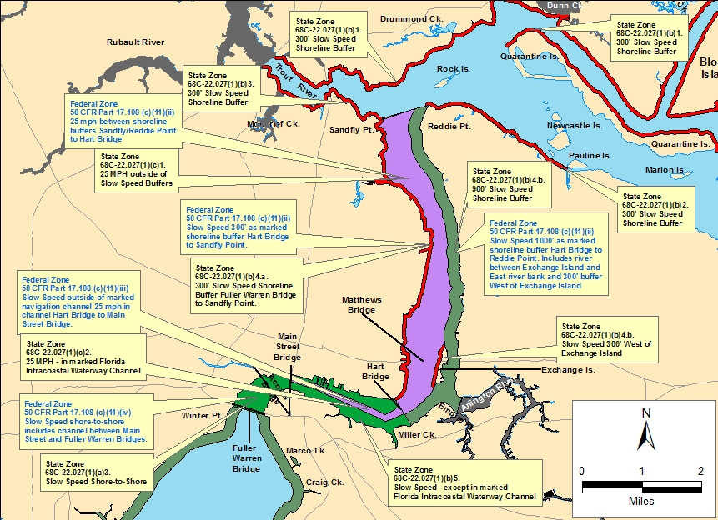

Figure 6: Federal (blue text), State and Local Manatee Protection Zones. Source: Jacksonville University.

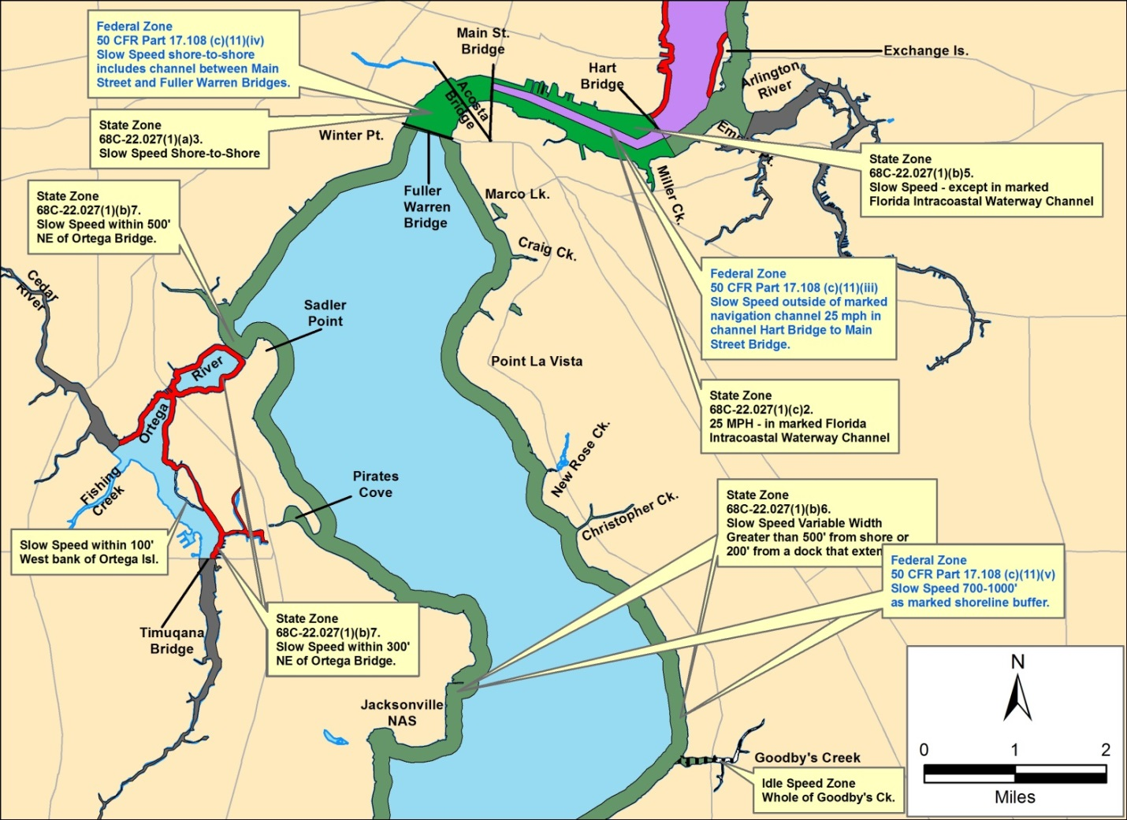
Figure 7: Federal (blue text), State and Local Manatee Protection Zones.

Solid grey shaded areas represent local Caution Manatee Awareness Zones. Source: Jacksonville University.

